Appointing Authority Roles that can sign for Donated Leave:
- Agency Director/Head of Agency
- Agency Payroll
- Agency HR
- HR Generalist 3

See below for the roles that are able to sign for donated leave. At least ONE of the following four roles must be checked on the SAR form in order to be able to sign as the Appointing Authority Signature.
- HR Generalist 3
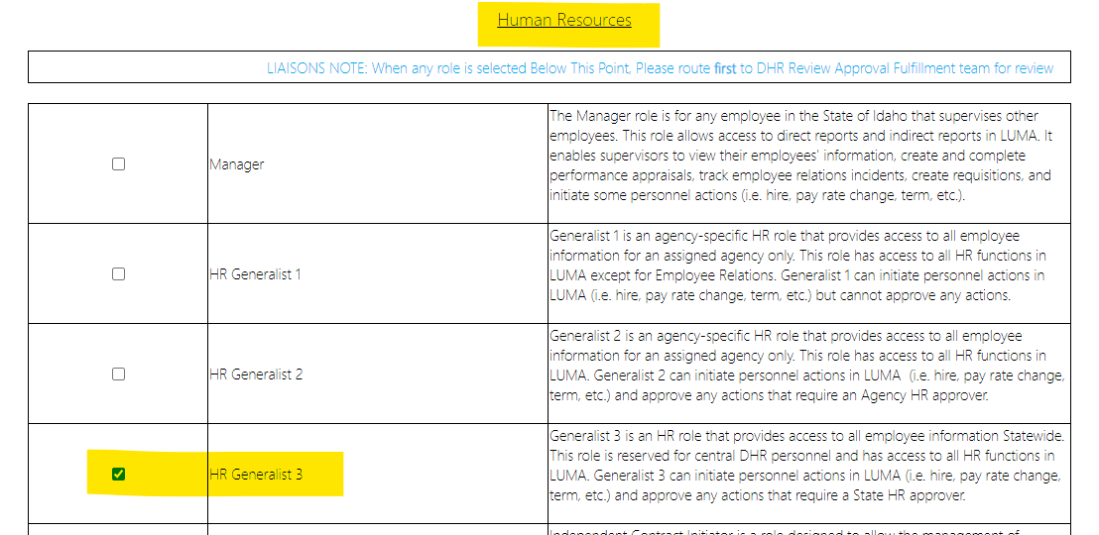

- Agency Payroll (under WFM, not Agency Payroll Administrator)
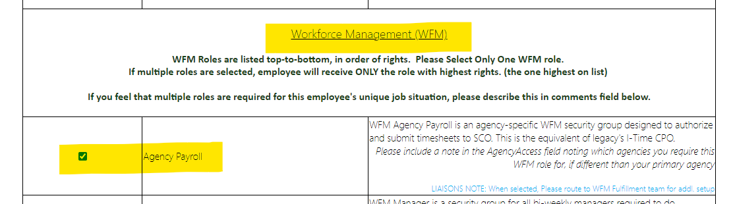

- Agency HR (under Approval Workflow Security, not Agency HR under WFM)

- Agency Director or Head of Agency (under Additional Authority)
